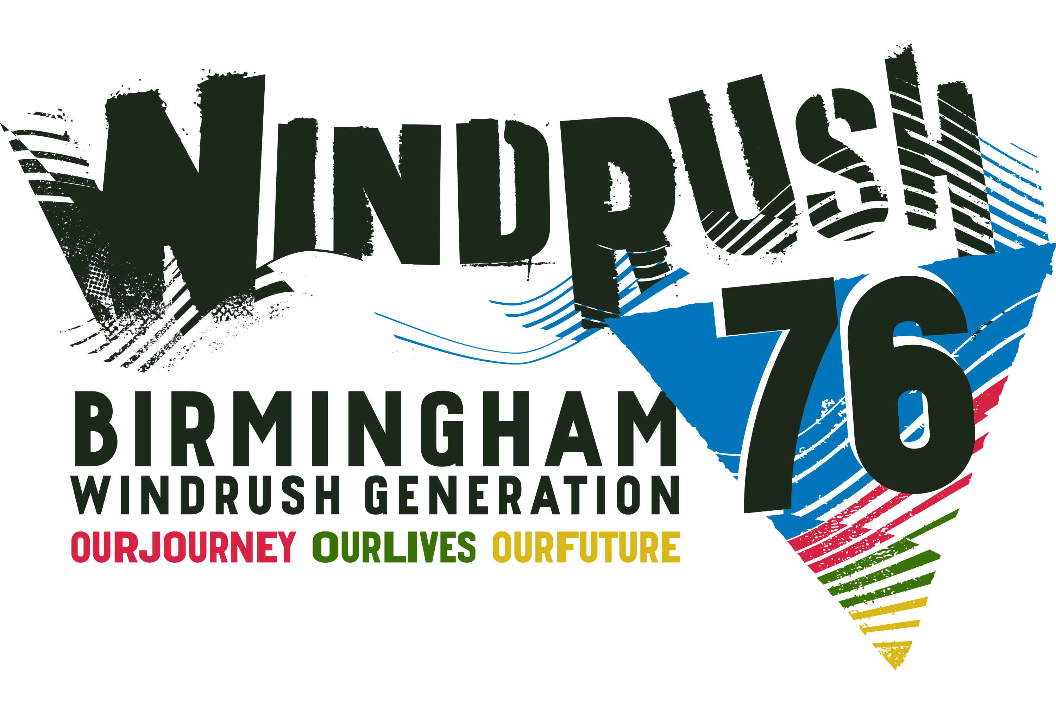

**WINDRUSH 2024**

**Events Brochure Submission**

Monday 3 June to Sunday 30 June 2024

Blackstory Partnership CIC is producing **Windrush 2024 Brochure of Events,** that will be taking place in the West Midlands during the month of June. If you are planning an event, activity or exhibition during **June 2024** and would like it to appear in the brochure, please complete the online submission for here:

You can email **[blackstorypartnership@gmail.com](mailto:blackstorypartnership@gmail.com)** for a submission form.

Completed forms must be returned by emailing **[blackstorypartnership@gmail.com](mailto:blackstorypartnership@gmail.com)**

**DEADLINE for completed forms is FRIDAY 26 APRIL 2024**

**Please use a separate form for each event.**

If your event or activity is charging for attendance, there will be a £25 fee for your entry. If your event is a free, there will not be a fee to be included in the brochure. Please note we cannot guarantee your entry will be included if your submission is received after that date.

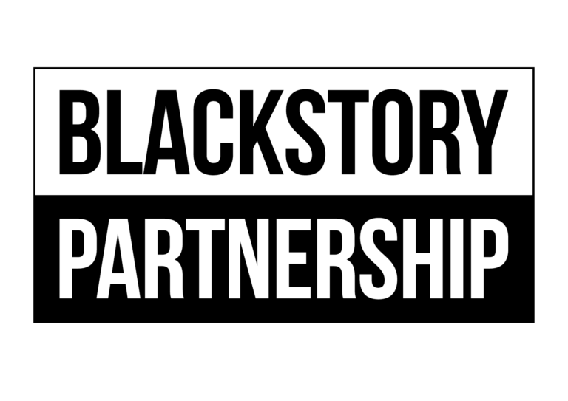

Event Title:

Name:

Date:

Time:

Venue Address:

Ticket Price (include concessions)

Description – Maximum 40 words

Box Office No and Website

Organisations Website/Link

Organisation Name:

Email address:

Telephone Number :(Day) (Mobile)

Image upload: If available please include any print quality Hi Res JPG files with an image size of at least 15cm wide and 300dpi. Please list any image credits and email blackstorypartnership@gmail.com