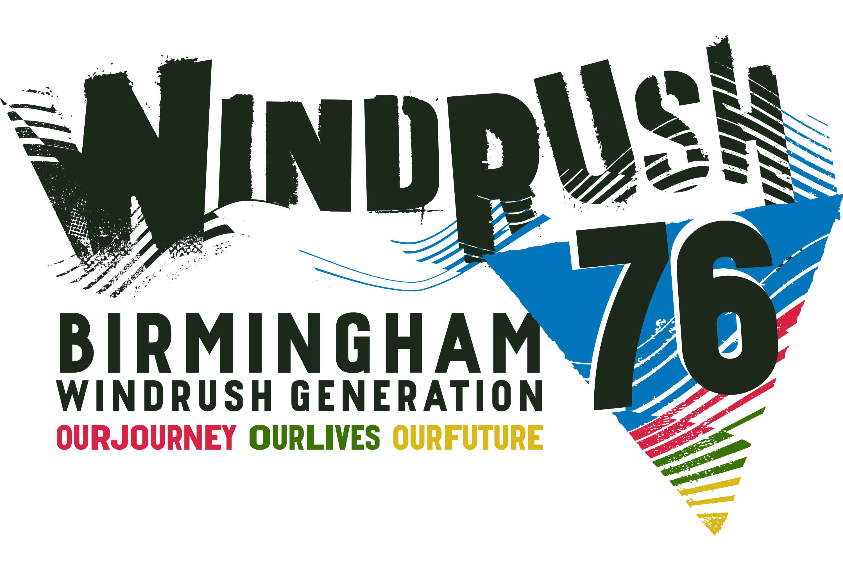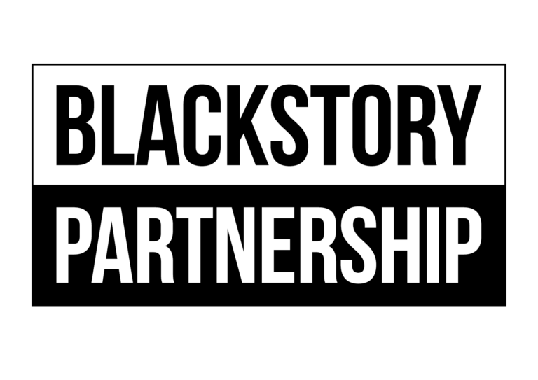

**WINDRUSH 2024**

**Events Brochure Submission**

Monday 3 June to Sunday 30 June 2024

Blackstory Partnership CIC is producing **Windrush 2024 Brochure of Events,** that will be taking place in the West Midlands during the month of June. If you are planning an event, activity or exhibition during **June 2024** and would like it to appear in the brochure, please complete the online submission for below and you can email**: [blackstorypartnership@gmail.com](mailto:blackstorypartnership@gmail.com)** for a submission form. Completed forms must be returned by emailing **[blackstorypartnership@gmail.com](mailto:blackstorypartnership@gmail.com)**

**DEADLINE for completed forms is FRIDAY 26 APRIL 2024**

**Please use a separate form for each event.**

Venue Address:

Telephone Number :(Day) (Mobile)

Email address:

Description – Maximum 40 words

Box Office No and Website

Name:

Organisation Name:

Event Title:

Date:

Organisations Website/Link

Time:

Ticket Price (include concessions)

Image upload: If available please include any print quality Hi Res JPG files with an image size of at least 15cm wide and 300dpi. Please list any image credits and email [blackstorypartnership@gmail.com](mailto:blackstorypartnership@gmail.com)

If your event or activity is charging for attendance, there will be a £25 fee for your entry. If your event is a free, there is a fee of £10 for the event to be included in the brochure.

Please note we cannot guarantee your entry will be included if your submission is received after that date. If your event or activity is charging for attendance, there will be a £25 fee for your entry. If your event is a free, there will

not be a fee to be included in the brochure. Please note we cannot guarantee your entry will be included if your submission is received after that date.