
BIRMINGHAM BLACK HISTORY MONTH
BROCHURE SUBMISSION FORM

Monday 28 Sept to Sunday 1 Nov 2026
Birmingham City Council has commissioned Blackstory Partnership CIC to
produce Birmingham’s Black History month 2026 brochure. The brochure
will be available in hard copy and online digital format. If you are planning
an event, activity or exhibition in the Birmingham during October and
would like it to appear in the listings, please email the completed form to
blackstorypartnership@gmail.com

Please use a separate form for each event.

The deadline for submitting your form is Sunday 23rd August 2026.

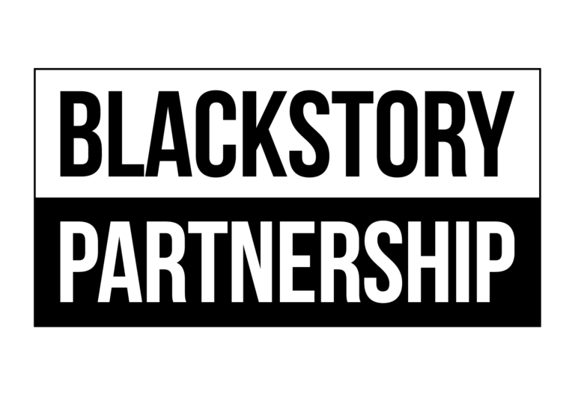

Date:
Event Title:
Image upload: If available please include any print quality Hi Res JPG files with an image size of at least 15cm wide and 300dpi. Please list any image credits and email blackstorypartnership@gmail.com
Organisations Website/Link

Description – Maximum 40 words
Box Office No and Website
Name:
Venue Address:
Ticket Price (include concessions)
Organisation Name:
Telephone Number :(Day) (Mobile)
Time:
Email address:

